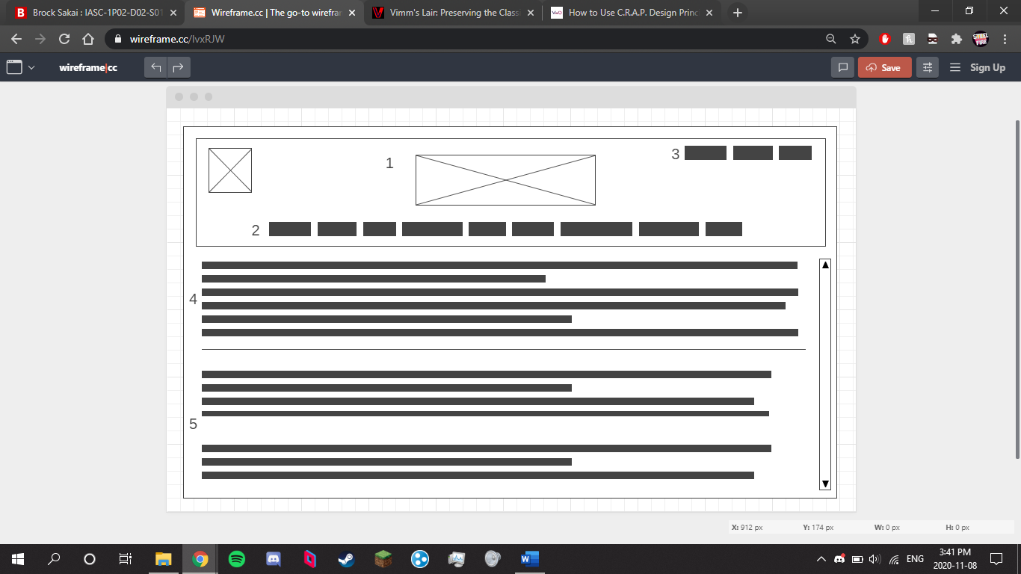I am redesigning Vimm’s Lair, a website made to house ROMs of old games for the sake of preserving them for future generations.  
  
<https://vimm.net>

**Rationale:** The original site’s main problem is its problem with alignment. And colour. Although the site’s look is not necessarily bad, it comes off as looking very dated by modern standers. As such, this redesign focuses more on making the presentation and layout more familiar to viewers and to update its look to feel more modern by moving around the navigation bar, reorganizing the main content section to be left aligned and moving the communications section to better highlight it. The redesign also changes the colours used in the site, keeping the blue, but shifting the red to a more orange tint to better fit a complementary colour design.

**Item 1**

Description: Header

Font: Calibri 30px

Font Color: White

Color: DarkBlue

Alignment: Center

Media: Logos

**Item 2**

Description: Nav Bar

Font: Arial 10px

Font Color: White

Color: OrangeRed

Alignment: Center

Media: N/A

Interactivity: Site navigation links

**Item 3**

Description: Social

Font: Arial 10px

Font Color: White

Color: DarkBlue

Alignment: Right

Media: Social icons

Interactivity: Links to social webpages

**Item 4**

Description: Page Description

Font: Arial 12px

Font Color: White

Color: Black

Alignment: Left

Media: N/A

**Item 5**

Description: Main content

Font: Arial 12px

Font Color: White

Color: Black

Alignment: Left

Media: N/A